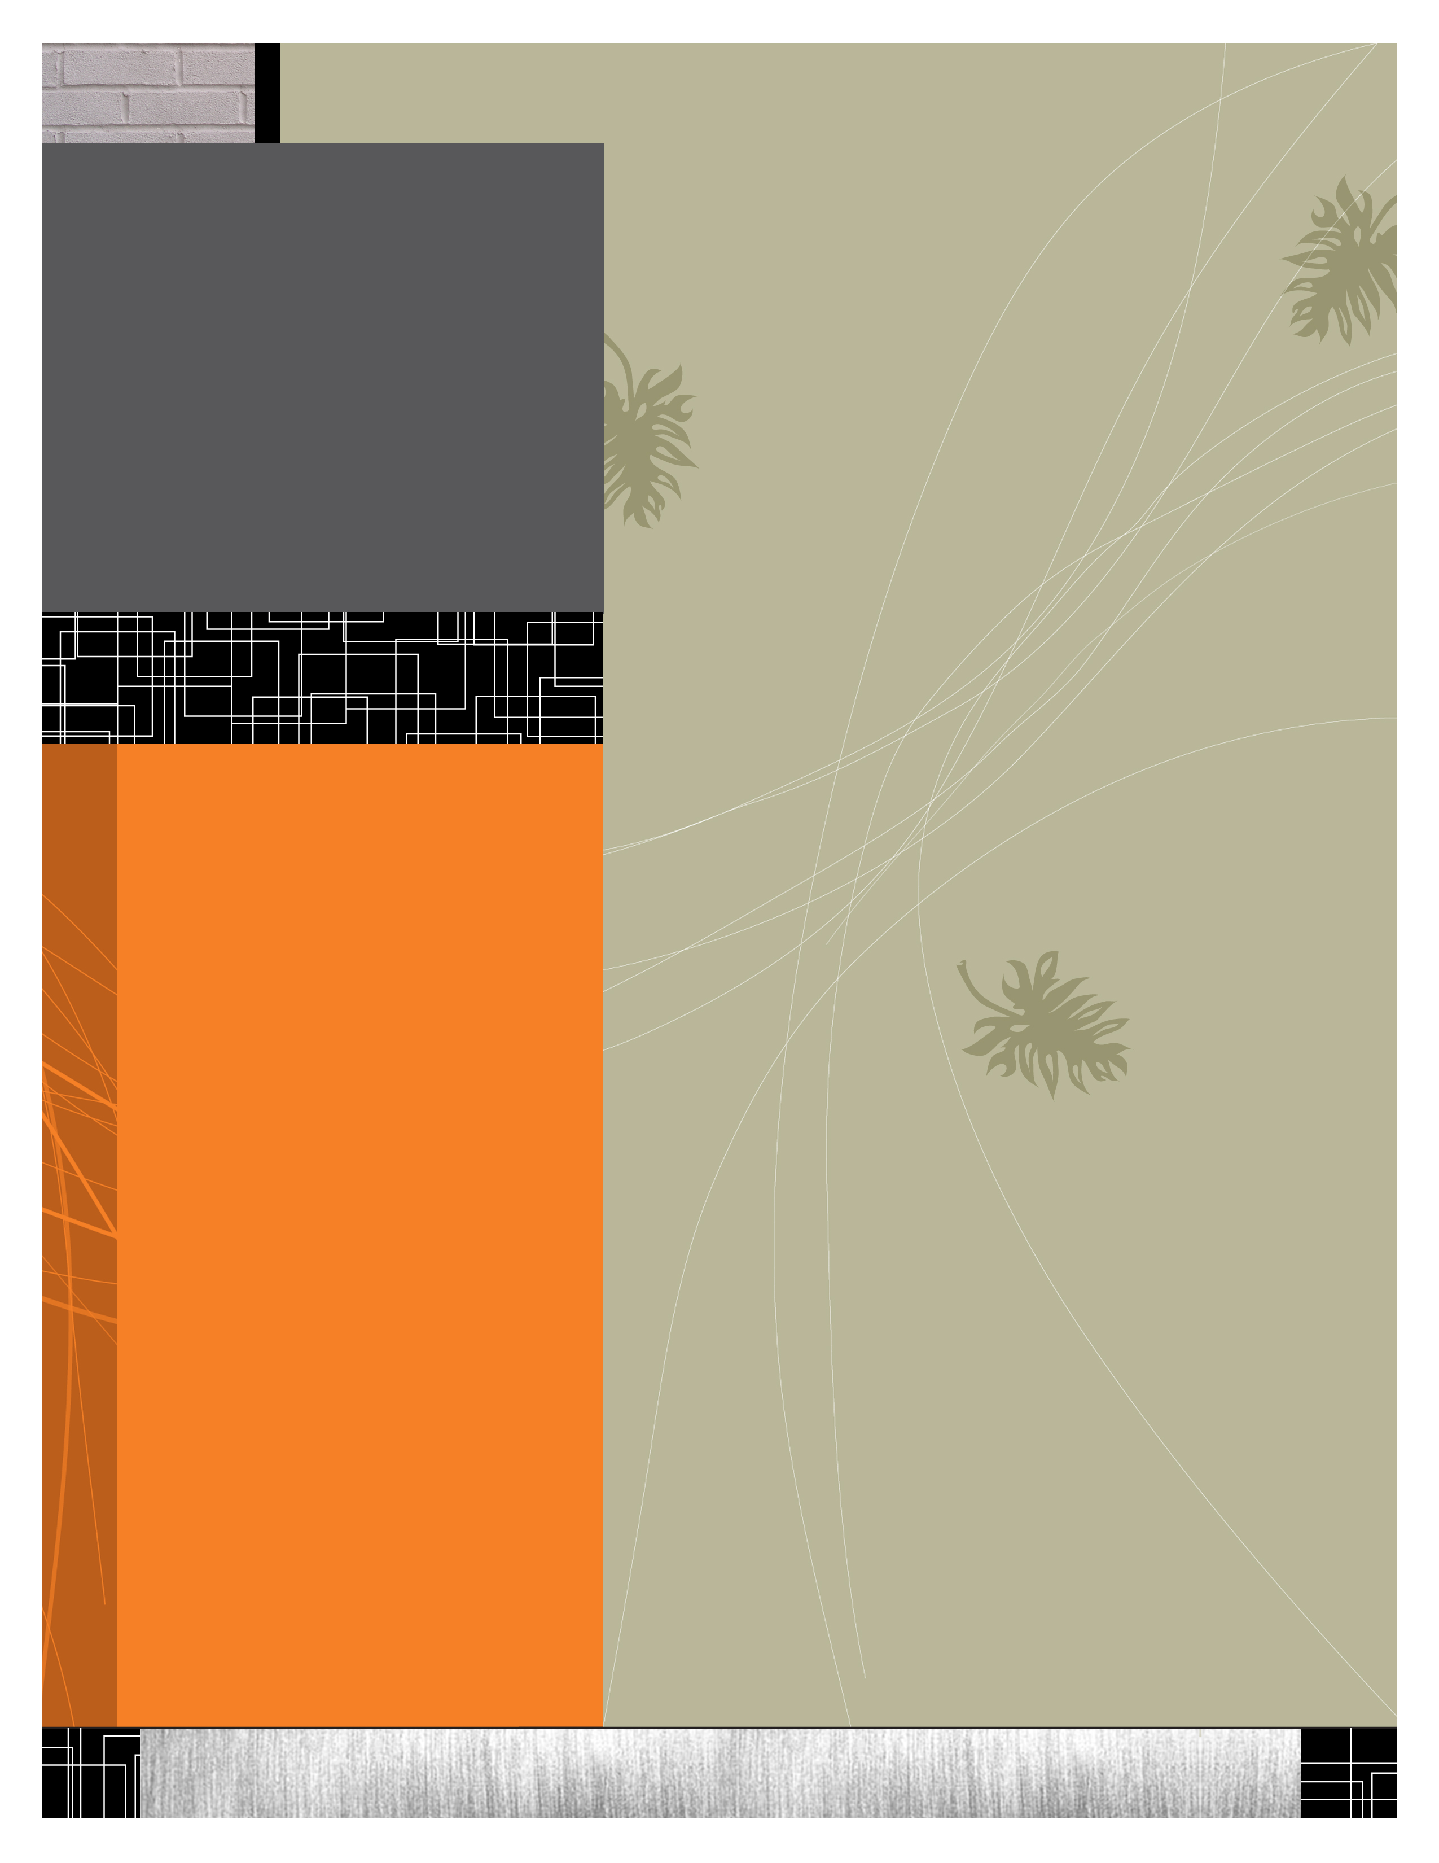
Book Review: What If? Writing Exercises for Fiction Writers by Anne Bernays and Pamela Painter (ISBN: 978-0-06-272006-1).

Exercise for Your Brain
By Cheri Powell

As an aspiring fiction writer, I am always on the lookout for any tips or tricks that will instantly turn me into a best-selling author. Unfortunately, I have been unable to locate the holy grail of writing, but in the process of looking, I have amassed an impressive collection of books that have helped me toward my goal. One book that has helped me the most is What If? Writing Exercises for Fiction Writers by Anne Bernays and Pamela Painter (ISBN: 978-0-06-272006-1).
A big problem for me as I tried writing my first stories was that I did not know where to begin. I did not know what I did not know. Consequently, I didn’t know what questions to ask. This book solved that problem. It is written by two women who collectively have over twenty-five years of teaching creative writing. That alone gives them credibility, but, they have also published several novels and short stories. They know how to get published. With those credentials going for them, I am ready to listen to their advice.
The book is a compilation of exercises, each concerned with some aspect of writing. Some are geared for the beginning writer and some are more advanced.
The range of exercises covers all important aspects of writing. There are four or five different exercises under each of the following headings: Beginnings, Notebooks, Journals and Memory, Characterization, Perspective
Continued on page 2: Exercise for Your Brain

August 2010 VOL 2 ISSUE 10

Women who write, inc.
Encouraging, supporting and educating women who aspire to write
WRITER’S WIRE
The newsletter for women writers in the know.
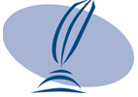.
Women Who Write, Inc.
www.womenwhowrite.com

Around the Town for Writers
August 2010
August 5, 2010 Louisville-- Monthly meeting of Women Who Write Highlands Branch of LFPL located at 1250 Bardstown Rd, Louisville meeting begins at 6:30 p.m.

Sat Aug 21 -- Frankfort -- Annual Gathering of Authors at the Paul Sawyier Public Library, 10:00am until 3:00pm.

Mon Aug 30 -- Louisville -- Don Bogen is featured in the Sarabande Reading Series at 21C Museum/Hotel

Calls for Submissions

Accents Publishing, www.accents-publishing.com, seeks poems of up to 50 words for an anthology of very short poems,

Still: The Journal announces its first annual literary contest
Tennessee Williams/New Orleans Literary Festival Poetry Contest
A prize of $1,000 and publication

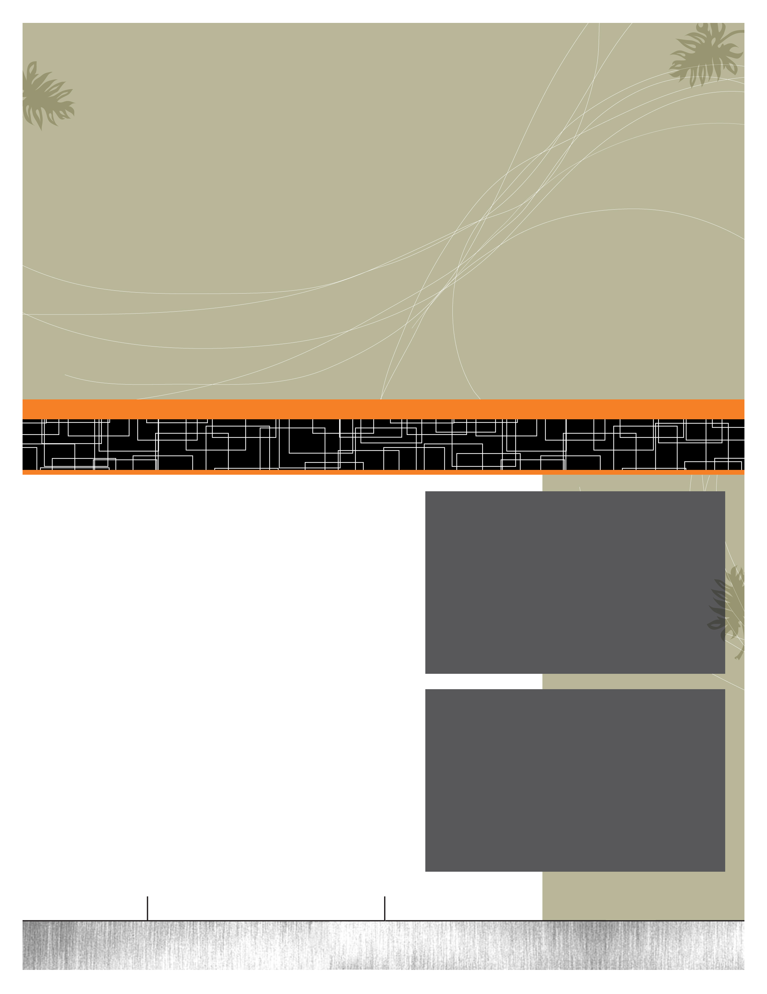
Names in the News
Judith C. Owens-Lalude will be participating in the Kentuckians Readings, sponsored by The Giles Society. It will be held on Saturday, September 18, 2010, from 9:00 a.m. to 3:00 P.M. (CDT).

Cheri Powell’s new book, “Seven Tips to Make the Most of the Camino de Santiago” will be released on Amazon.com next week! The book cover (below) features a picture of her husband Rick. “We were high in the Pyrenees and a fog was rolling in which restricted vision for seeing the signposts. Luckily we began a descent which took us out of the fog and to our destination for that day.” Cheri Powell
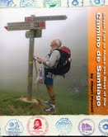 Congratulations Judith and Cheri!

August 2010 VOL 2 ISSUE 10

Continued from page 1: Exercise for Your Brain
and Point of View, Dialogue, Plot, Story Elements as a Given, Resolution and Final Meaning, Invention and Transformation, Mechanics, Games and Learning from the Greats.
When I first purchased the book, I was concerned about whether I was completing the exercises correctly. I posed the concern to a professor friend of mine who assured me that the simple act of thinking about and completing the exercise was enough to have an effect. I have since stopped worrying about correctness in favor of letting ideas flow.
While I have not completed all the exercises in the book, I have completed enough to recommend it highly. It has made me much more aware of what I am doing, so that my work (hopefully) is becoming better crafted. I think about what I am doing and, if I get stuck, I will go to this book to see if there is an exercise that will help me. Now if there were only a chapter on book reviews……..

Cheri Powell is the author of “Seven Tips to Make the Most of the Camino de Santiago” and a member of Women Who Write, her email address is writing_cheri@yahoo.com.

If you have been published or have received an award or accolade in your writing career please let us know. Send your news to info@womenwhowrite.com



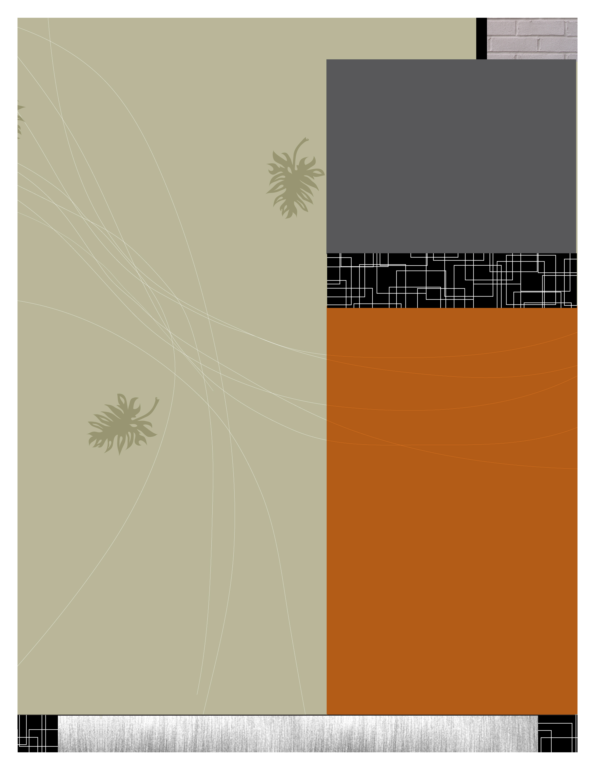
By Peggy Barnes DeKay
“A podcast (or non-streamed webcast) is a series of digital media files (either audio or video) that are released episodically and often downloaded through web syndication. “ source:Wikipedia
What? It sounds complicated but it’s not. Let’s take it one step at a time. A podcast is usually an audio mp3 file that can be copied onto a hard drive, iPod or a CD and listened to on any device that can play an mp3 file. “Non-streaming” means it is not “live” but loaded in episodes, one at a time. The syndicator is the entity that distributes the podcast file to users. iTunes (www.iTunes.com) is one of the best known syndicators. All I have to do is setup an iTunes account, and search the iTunes library for “podcasts.” My search can be refined allowing me to search by subject. How can podcasting help authors? Non-fiction writers, use podcasts to discuss the topics they cover in their books. For instance, if I write a book called “The Perfect Vegetable Garden,” I could promote my book by talking with experts on vegetable gardening, or how to prepare the soil. How about 30 minutes on types of fertilizer? These talks can be compiled into a series which can then be put into a folder and accessed any time I want them. If I subscribe to a podcast series iTunes will notify me when a new podcast in that series is released. When you inventory your podcast on iTunes you can embed a link to your Web site. People who hear your podcast can go to your Web site and learn more about you and your books.
(This is part 1 of a 2 part article on podcasting, see September 2010 Women Who Write Writer’s Wire for part 2)

August, 2010 VOL 2 ISSUE 10

Place your advertising here. For pricing information contact info@womenwhowrite.com

podcasting: a tool for teaching while marketing


LETTER FROM THE EDITOR
It’s the month of August, a significant month for women in the United States. On August 19, 1920 the Nineteenth Amendment to the Constitution of the United States of American, giving women the right to vote, was ratified. The Amendment was passed by Congress on June 4, 1919, and ratified on August 19, 1920. 2010 marks 90 years since women have had the right to vote. While many other rights have come after, perhaps the most cherished and groundbreaking achievement was the right to vote.
As American women we arguably enjoy freedoms that other women around the world do not.
When you go to your polling booth this year to pull the lever, take a moment to reflect on those women who went before and braved brutality, humiliation and even imprisonment to give us that right. Let us never forget.
Peggy Barnes DeKay

YOUR AD HERE
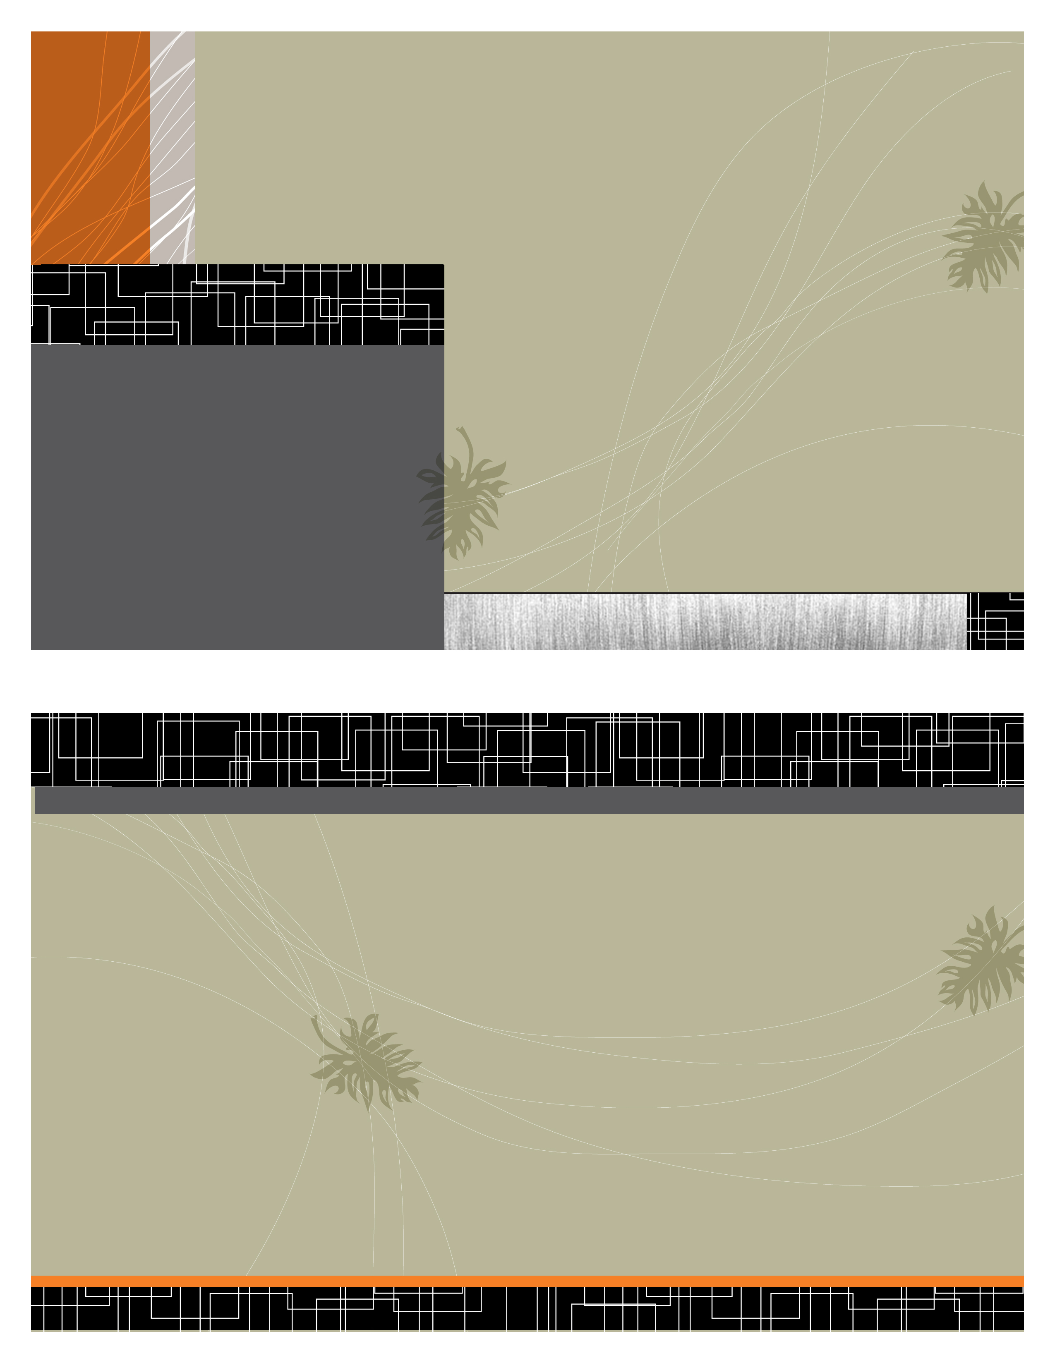
WOMEN WHO WRITE, INC.

Meetings and membership
Our goal is to encourage, support and educate all women who aspire to write. Our group is diverse and dynamic. If you are beginning your writing journey, a newly published writer, or in the middle of your career, there is something here for you. Membership entitles you to the following benefits: reading critiques, guest lecturers, workshops, writing contests, publication in our annual anthology, participation in public readings, five complimentary copies of our annual anthology (a $50.00 retail value) and participation in our annual weekend retreat.

Come and grow with us!

Meeting Times and Locations
1st Thursday each month in Highlands Library Branch
Mid City Mall 1250 Bardstown Road
6:30 P.M. – 8:30 P.M.

August 2010 VOL 2 ISSUE 10

P: 502-541-4670
E: info@womenwhowrite.com

A: PO Box 6167
Louisville, KY 40206-0167

W: www.womenwhowrite.com
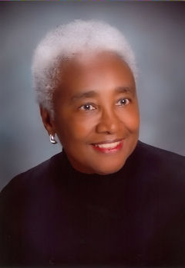
Women Who Write, Inc., a nonprofit 501c3 was co-founded in 1992 by Carridder “Rita” Jones, a playwright, author and historian.

